International Public Management Network 2017 Conference
16th-18th Aug 2017, Shanghai, China

Theme: Reform, Innovation and Governance:
Improving Performance and Accountability in Changing Times

Host:
- School of International and Public Affairs, Shanghai Jiao Tong University
- China Institute of Urban Governance, Shanghai Jiao Tong University
- Center for Reform, Innovation and Governance, Shanghai Jiao Tong University

Date: August 16-18, 2017

Venue: KoGuan Law School Building, Shanghai Jiao Tong University, Xuhui Campus, 1954 Huashan Rd., Xuhui District, Shanghai, China, 200030 -

Hotel Reservation: Shanghai Tianping Hotel, No.185 Tianping Road, Xuhui District, Shanghai(上海市徐汇区上海天平宾馆天平路185号)

Programme Overview
Wednesday, August 16, 2017
15:30-18:30 p.m. Registration at Tianping Hotel
18:30-20:30 p.m. Welcome Dinner at Tianping Hotel, 3rd Floor (Buffet)
Thursday, August 17, 2017
08:00a.m. Meet at the Hotel Lobby and Walk to the Campus Together
08:00-08:30a.m. Registration, 2nd Floor, KoGuan Law School Building
08:30-10:40a.m. Opening Ceremony & Keynote Address, Room 208 (East Conference Hall), KoGuan Law School Building
10:40-11:00 a.m. Tea Break (include group photo taking), 2nd Floor, KoGuan Law School Building
11:00-12:30 a.m. Parallel Session I
Break-Out Sessions
1a: Room 202, KoGuan Law School Building
1b: Room 204, KoGuan Law School Building
1c: Room 205, KoGuan Law School Building
12:30 -13:45p.m. Lunch at SAIF Canteen (2nd Floor, Buffet)
13:45-15:30p.m. Parallel Session II
Break-Out Sessions
2a: Room 202, KoGuan Law School Building
2b: Room 204, KoGuan Law School Building
2c: Room 205, KoGuan Law School Building
15:30-15:45 p.m. Tea Break, 2nd floor, KoGuan Law School Building
15:45-17:15p.m.Parallel Session III
Break-Out Sessions
3a: Room 202, KoGuan Law School Building
3b: Room 204, KoGuan Law School Building
3c: Room 205, KoGuan Law School Building
17:15-18:15p.m. IPMN Board Meeting (Room 202, Open to all conference attendants)
18:30-20:30 p.m. Reception, Faculty Club, SJTU
Friday, August 18, 2017
9:00-10:30a.m. Parallel Session IV
Break-Out Sessions
4a: Room 202, KoGuan Law School Building
4b: Room 204, KoGuan Law School Building
4c: Room 315, KoGuan Law School Building
10:30-10:50 Tea Break, 2nd floor, KoGuan Law School Building
10:50-12:00p.m. Open Discussion& Closing Ceremony
Room 202, KoGuan Law School Building
12:10-13:30p.m. Lunch at SAIF Canteen (2nd Floor, Buffet)
13:30-16:30p.m. Social Programme: Site Visit to the Administrative Citizen’s Service Center in Shanghai’s Xuhui District (Special Registration Required at the Hotel Registration)

Committee Chairs:
Jiannan Wu
Distinguished Professor, Shanghai Jiao Tong University
Email: jnwu@sjtu.edu.cn

Clay Wescott
President, International Public Management Network
Email: clay.wescott@gmail.com

Academic Committee:
Chan, Hon | City University of Hong Kong
Choi, Heungsuk | Korea University
Ear, Sophal | Occidental College
Im, Tobin | Seoul National University
Jing, Yijia | Fudan University
Kelman, Steven | Harvard University
Kotchegura, Alexander | Russian University of Peoples` Friendship, RUDN
Lægreid, Per | University of Bergen
Liu, Bangcheng | Shanghai Jiao Tong University
Moon, M. Jae | Yonsei University
Murdock, Alex | London South Bank University
Podger, Andrew | Australian National University
Riccardo, Mussari | University of Siena
Roberts, Alasdair | University of Missouri
Roberts, Nancy | Naval Post Graduate School
Schedler, Kuno | University of St Gallen
Thompson, Fred | Willamette University
Walker, Richard | City University of Hong Kong
Wang, Wen | Rutgers University-Newark
Wright, Bradley E． | University of Georgia
Wu, Xun | Hong Kong University of Science and Technology
Yang, Kaifeng | China Renmin University
Yang, Yongheng | Tsinghua University
Zhao, Zhirong Jerry | Minnesota University
Zhu, Xufeng | Tsinghua University

Detailed Conference Agenda
Wednesday, August 16, 2017
15:30-18:30 p.m. Registration
Venue: Shanghai Tianping Hotel Lobby

18:30-20:30 p.m. Welcome Dinner at Shanghai Tianping Hotel
Venue: 3rd floor, Shanghai Tianping Hotel
Host: Bangcheng Liu
Vice Dean, School of International and Public Affairs
Shanghai Jiao Tong University
Welcome Address:
Jiannan Wu
Distinguished Professor, Executive Vice Director, China Institute of Urban Governance
Director, Center for Reform, Innovation and Governance
Shanghai Jiao Tong University
Clay Wescott
President of IPMN

Thursday, August 17, 2017
08:00-08:30a.m.
Registration
Venue: 2nd floor, KoGuan Law School Building, SJTU
8:30-10:40a.m. Keynote Address
Venue: Room 208 (East Conference Hall)
Host: Jiannan Wu
Distinguished Professor, Executive Vice Director, China Institute of Urban Governance
Director, Center for Reform, Innovation and Governance
Shanghai Jiao Tong University
Keynote Address:
- Unleashing Change in Government
Speaker: Steven J. Kelman, Weatherhead Professor of Public Management, Kennedy School of Government, Harvard University
- Is There a Nordic Model of Administrative Reform?
Speaker: Per Lægreid, Professor at the Department of Administration and Organization theory, University of Bergen
- Public Service Innovation: Towards a Typology
Speaker: Richard M. Walker, Professor, City University of Hong Kong

10:40-11:00 a.m. Tea Break(including group photo taking)
Venue: 2nd floor, KoGuan Law School Building

11:00-12:30 p.m. Parallel Session I
Sub-theme1a: How to Implement Reform Strategies of State and Local Authorities
Venue: Room 202, KoGuan Law School Building
Moderator: Hon Chan (City University of Hong Kong)
Discussant: Xufeng Zhu (Tsinghua University)
- Implementing Governance Reform in China: A Comparative Study of Environmental Service Organization Reform in Chengdu and Guangzhou
Xueyong Zhan (Hong Kong Polytechnic University)
- Devolution: A reality or rhetoric Case of 2001 Devolution in Environmental Protection Departments, Pakistan
Zahra Paul (University of the Punjab)
- 20 Years After Handover: A Review of Public Management Reform In Hong Kong
Richard Lui (Tianda Institute, Hong Kong)
- Local Government Reform in Pakistan: Past, Present and Future
Ayesha Hanif (University of the Punjab)

Sub-theme1b: How to Promote Innovations in Public and Private Sectors
Venue: Room 204, KoGuan Law School Building
Moderator: Richard M. Walker (City University of Hong Kong)
Discussant: Lei Guo (Tongji University)
- What Drives Government Innovativeness?: Evidence from the US States
Bin Chen (Baruch College/CUNY), Liang Ma (Renmin University of China)
- How smart can government be? – Discussing the potential of smart technologies for public administration
Kuno Schedler, Ruth Frischknecht, Ali Asker Gündüz (University of St.Gallen)
- Spatial Patterns and Determinants of Local Sustainability Experimentation in China during 2006-2010: A Spatial Econometric Analysis
Jie Wang (Tsinghua University), Yue Guo(Beijing Normal University)
- Public provision by the private sector: a four country comparison of emergency ambulance services
Alex Murdock (London South Bank University)

Sub-theme1c: How to Improve Governance through Reform and Innovation
Venue: Room 205, KoGuan Law School Building
Moderator: Per Lægreid (University of Bergen)
Discussant: Fanrong Meng (Xi'an Jiaotong University)
- Innovation, Governance and Reform of Development Partnerships
Clay G. Wescott (President, International Public Management Network)
- Spatial production and governance of urban agglomeration in China 2000-2015: Yangtze River Delta as a case
Chao Ye (East China Normal University)
- A Cross-country Study of Communications Regulators from Taiwan, South Korea, Japan, Singapore, People Republic of China, and Malaysia
Kuo-Tai Cheng (National Tsing Hua University)
- Environmental Target-setting and the Adoption of Policy Tools with Spatial Spillover Effects: Evidence from Mainland China
Pan Zhang, Jiannan Wu (Shanghai Jiao Tong University)

12:30 -13:45p.m. Lunch at SAIF Canteen (2nd Floor)

13:45-15:30p.m. Parallel Session II
Sub-theme2a: How to Implement Reform Strategies of State and Local Authorities
Venue: Room 202, KoGuan Law School Building
Moderator: Tom Christensen (University of Oslo)
Discussant: Yan Bo (Xi'an Jiaotong University)
- Public-Private Differences with incentive structures: A laboratory experiment of work motivation and performance
Jin Lee, Richard M. Walker (City University of Hong Kong)
- A Tale of Two Cities: How Smog Crisis Influence Public Acceptance towards Congestion Charge Policy--Learning from Beijing and Shanghai
Lingyi Zhou, Yixin Dai (Tsinghua University)
- “Where There’s a Reform Process, There’s Performance”: Does This Reflect Reality ? The Experience of Managerial Reform in French Public Universities
Roula Masou (ESSCA School of Management)

Sub-theme2b: How to Promote Innovations in Public and Private Sectors
Venue: Room 204, KoGuan Law School Building
Moderator: Alex Murdock (London South Bank University)
Discussant: Kilkon Ko (Seoul National University)
- Multiple Mechanisms of Innovation Diffusion in China
Xufeng Zhu (Tsinghua University)
- Beyond bureaucracy: The Effects of Environmental Policy Experimentation on Citizens' Environmental Awareness in Urban China
Yue Guo(Beijing Normal University), Jie Wang (Tsinghua University)
- Governing innovation networks: Findings from a case study in Nanjing
Yanwei Li (Nanjing Normal University)

Sub-theme2c: How to Improve Governance through Reform and Innovation
Venue: Room 205, KoGuan Law School Building
Moderator: Carmine Bianchi (University of Palermo)
Discussant: Liang Ma (Renmin University of China)
- Background and Career Trajectories of Political and Administrative Elite: The Case of Russia and Japan.
Alexander Kotchegura (Russian University of Peoples` Friendship, RUDN)
- Performance management in the public sector: A case study of Vietnam as a transitional country
Tai Anh Vu (Victoria University of Wellington)
- How to Improve the Work Engagement of Basic Level Civil Servants? Evidence from Mainland China
Huan Wang, Fanrong Meng, Sihan Li (Xi'an Jiaotong University)
- Corporate Governance and Transparency in Spanish Central Government Agencies
Vicente Pina, Lourdes Torres (University of Zaragoza, Spain)

15:30-15:45 p.m. Tea Break

15:45-17:15p.m. Parallel Session III
Sub-theme3a: How to Implement Reform Strategies of State and Local Authorities
Venue: Room 202, KoGuan Law School Building
Moderator: M. Jin Lee (City University of Hong Kong)
Discussant: Yue Guo(Beijing Normal University)
- Decentralization, Incentives, and Tax Enforcement
Junxue Jia, Yongzheng Liu, Siying Ding (Renmin University of China)
- Does the Land Financing Inhibit Regional Innovation? Preliminary Empirical Evidence from China
Bo Yan (Xi'an Jiaotong University), Jiannan Wu (Shanghai Jiao Tong University)
- External Perturbation, Institutional Contradictions, and Change Entrepreneurship in Local Government Reforms in Authoritarian China
Zhenjie Yang (Zhongnan University of Economics and Law)
- The Province-Managing-County Reform and County-level Urbanization: An Empirical Analysis on Panel Data of Shaanxi Province
Jia Liu (Shaanxi Normal University), Yanru Huang, Bo Yan (Xi'an Jiaotong University)

Sub-theme3b: How to Improve Governance through Reform and Innovation
Venue: Room 204, KoGuan Law School Building
Moderator: Yijia Jing (Fudan University)
Discussant: Tang Tian (Florida State University)
- Institutional Development and Budgetary Outcome: The case of Hong Kong
Hanyu Xiao (City University of Hong Kong)
- Changing Intergovernmental Relationship and Administrative Reforms: the case of China
Ruiliang Zhang (Renmin University of China)
- The Impact of Institutional Development on Environmental Spending
Jingyuan Xu (City University of Hong Kong)
- The Impact of Institutional Development on Social Welfare Spending
Chenlin Zhao (City University of Hong Kong)

Sub-theme3c: How to Improve Governance through Reform and Innovation
Venue: Room 205, KoGuan Law School Building
Moderator: Kuno Schedler (University of St.Gallen)
Discussant: Yixin Dai (Tsinghua University)
- Crisis Management Capacity in Central Government: the Perceptions of Civil Servants in Norway
Tom Christensen (University of Oslo), Per Lægreid (University of Bergen)
- Resource Dependence and Efficiency of Quasi-Governmental Institutions
Kilkon Ko , Daejoon Kim, Yeyoung Lee ( Seoul National University)
- Using Financial Management Information Systems (FMIS) for Fiscal Control: Applying a Risk-Based Approach for Early Results in the Reform Process.
Clay G. Wescott (President, International Public Management Network)
- Understanding inter-organisational relationships in public-private partnerships: A study of educational PPPs in Pakistan
Sidra Irfan (University of the Punjab)

17:15-18:15p.m. IPMN Board Meeting (Open to all conference attendants)
Venue: Room 202, KoGuan Law School Building

18:30-20:30 p.m. Reception
Venue: Faculty Club, SJTU

Friday, August 18, 2017
9:00-10:30a.m. Parallel Session IV
Sub-theme4a: How to Implement Reform Strategies of State and Local Authorities
Venue: Room 202, KoGuan Law School Building
Moderator: Chao Ye (East China Normal University)
Discussant: Xueyong Zhan (Hong Kong Polytechnic University)
- Does Environmental Protection Interview Really Matter to Air Pollution Control: A Multiple-Case Study from China
Jiannan Wu, Jing Wen, Zhao Qin, Fanrong Meng (Shanghai Jiao Tong University)
- Same bed, different dreams?: Structural and functional integration of central government agencies in China
Liang Ma (Renmin University of China), Tom Christensen (University of Oslo)
- Vertical Management Reform in Environmental System in China: Progress, Conditions and Prospects
Fanrong Meng, Zitao Chen (Xi'an Jiaotong University)
- IPMR and Public Management: The next 18 years?
Stephen Barber, Alex Murdock (London South Bank University)

Sub-theme4b: How to Improve Governance through Reform and Innovation
Venue: Room 204, KoGuan Law School Building
Moderator: Alexander Kotchegura (Russian University of Peoples` Friendship, RUDN)
Discussant: Bin Chen (Baruch College/CUNY)
- Network Governance and Effectiveness on Renewable Energy Integration: A Comparative Case Study on Power Transmission Networks in the United States
Tang Tian (Florida State University)
- When Public-Private Partnerships Meet Financial Stress: Process and Choice in Restructuring Road Infrastructure Ventures
Yin Wang (Shanghai University of Finance and Economics)
- Can “Learned Helplessness” Theory Explain Negative Attitudes Among Public Personnel Towards- New Public Management Reforms?: A Case Study In Turkish Health Sector
Hamza Ates (Istanbul Medeniyet University, Turkey)
- The discretion of local governments in implementing central government' mandates: the case of environmental information transparency in China
Rui Zhao, Haitao Yin, Feng Wang, Junxiu Sun (Shanghai Jiao Tong University & Shanghai University of Finance and Economic)

Sub-theme4c: How to Improve Governance through Reform and Innovation
Venue: Room 315, KoGuan Law School Building
Moderator: Kilkon Ko (Seoul National University)
Discussant: Richard Lui (Tianda Institute, Hong Kong)
- Targets Heterogeneity, Ambiguity-Conflict and Policy Implementation: The Effect of Ownership on China’s Corporate Employee Pension Policy Implementation
Lei Guo (Tongji University)
- A Dynamic and Outcome-based Collaborative Approach to Crime Prevention: The Case of Malaysia
Carmine Bianchi (University of Palermo)
- Performance Assessment, Public Participation, or Both? Evidence from Environmental Protection across Chinese Provinces
Jiannan Wu, Mengmeng Xu, Pan Zhang (Shanghai Jiao Tong University)
- A Study on the Distribution Pattern of Supervision Policies About Online Car-Hailing Services and Taxi in China--Based on the Analysis of Evolutionary Game Model
Xintao Li (Tianjin University)
10:30-10:50 Tea Break

10:50-11:30 Open Discussion
Venue: Room 202, KoGuan Law School Building
Moderator: Clay G. Wescott (President, International Public Management Network)
- Publishing in IPMJ Steven J. Kelman (Harvard University)
- Publishing in IPMR Alex Murdock (London South Bank University)
- The Future of IPMN All the Participants

11:30-12:00 Closing Ceremony
Venue: Room 202, KoGuan Law School Building
Moderator: Kuno Schedler (Professor, University of St.Gallen)
Closing Remarks
Clay G. Wescott (President, International Public Management Network)
Jiannan Wu (Professor, Shanghai Jiao Tong University)

12:10-13:30 p.m. Lunch at SAIF Canteen (2nd Floor)

13:30-16:00p.m. Social Programme: Site Visit to the Administrative Citizen’s Service Center in Shanghai’s Xuhui District (Special Registration required at the Hotel Registration)
General Information
- Moderator: Each session will have a moderator, who ensures smooth procedures. Please have a look at the programme to check if you are moderating a session.
- Discussant: Every paper receives an oral feedback from the discussant for their papers and presentation. Please also have a look at the programme to check if you are a discussant of a session.
- Programme: We will provide you with a hard copy of the programme at the reception.
- Dress Code: Casual for all events.
- Parallel Session Agenda:
Each session consists of 3-4 presentations moderated by the moderator. Each gives a presentation about 15 minutes on their paper. The moderator is responsible for the introduction of each presenter, as well as the timing of each presentation and the following discussion. After all the presentation finish, the discussant will make comments on each paper for a total of 15 minutes and followed by a 15-30 minutes open discussion with all the presenters.
- Hotel Reservation:
We have reserved Shanghai Tianping Hotel(上海天平宾馆, Address: No.185 Tianping Road, Xuhui District, Shanghai), which is a close hotel to our Xuhui Campus(Address: 1954 Huashan Road, Shanghai, China, 200030) for the stay of our authors(Conference Period: 16th, 17th, 18th, 3 nights). You can find more information about the hotel online here: (http://www.tianpinghotel.com/en_US/index.html ). Please note that we have reserved one standard room for each paper, since we will only cover the accommodation for one of the authors.
- Directions & Transportations:
- From Shanghai Pudong International Airport to Shanghai Tianping Hotel
Suggested Transportation: Taxi takes about 50 minutes (47km, 30miles) without traffic, costs about 180 RMB (around 30 USD)
- From Shanghai Hongqiao International Airport to Shanghai Tianping Hotel
Suggested Transportation: Taxi takes about 30 minutes (17km, 10mile) without traffic, costs about 55 RMB (around 9 USD)
- From Shanghai Hongqiao Train Station to Shanghai Tianping Hotel
Suggested Transportation: Taxi takes about 30 minutes (14.4km, 9mile) without traffic, costs about 50 RMB (around 9 USD); You can also take Metro Line 10 from Hongqiao Railway Station stop to the Shanghai Jiao Tong University stop, which will take about 38 minutes including 13 minutes walk from Shanghai Jiao Tong University to Shanghai Tianping Hotel.
Reminder: You can also download a DiDi Chuxing App (Chinese version of Uber) in your smart phone to book a taxi to pick you up at the airport. You need to register an account and link your credit card to your account before making the reservation.
Learn more about School of International and Public Affairs:
Website: http://www.cpe.sjtu.edu.cn/
Learn more about China Institute of Urban Governance:
Website: http://ciug.sjtu.edu.cn/

To Explore More about the Great City, Shanghai
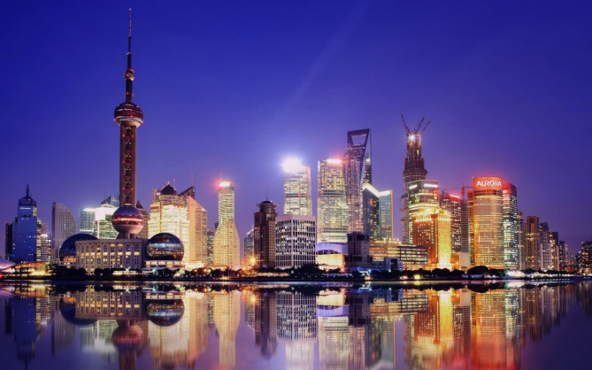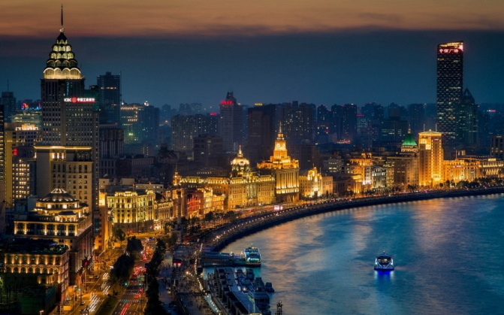
- Shanghai Taxi Info:
https://www.tripadvisor.com/Travel-g308272-c82538/Shanghai:China:Taxis.In.Shanghai.html
- Shanghai Maps: http://www.shanghaihighlights.com/shanghai-map
- Shanghai Subway Map:
http://www.shanghaihighlights.com/image/shanghai-map/shanghai-subway-map-2.jpg

To Explore More about Shanghai Jiao Tong University:
- Shanghai Jiao Tong University Website: http://en.sjtu.edu.cn/
- Campus Virtual Tour (3D maps): http://3dcampus.sjtu.edu.cn/en/index_EN.htm
- Old Buildings in the Xuhui Campus:
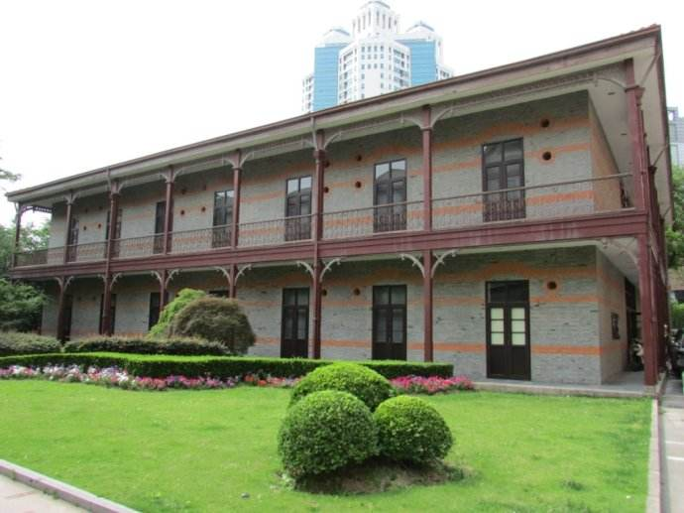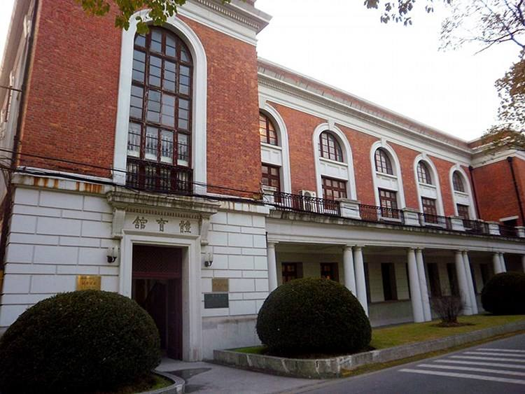

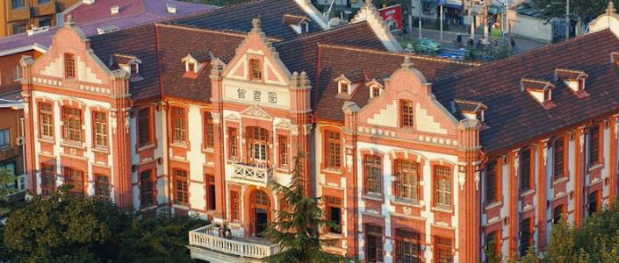
上海交通大学徐汇校区示意图(SJTU Xuhui Campus Map)
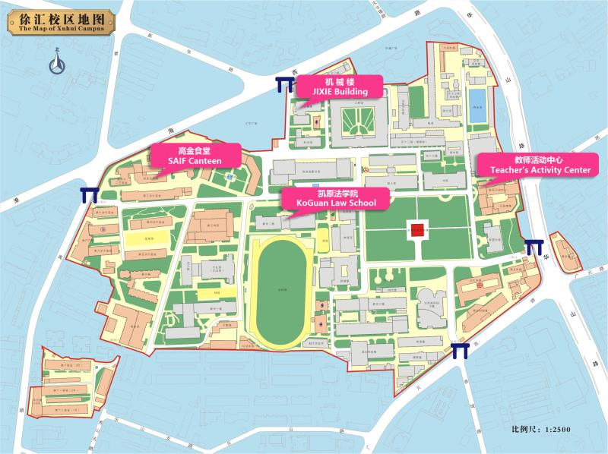 上海交大徐汇校区到天平宾馆路线
（From the Xuhui Campus to Shanghai Tianping Hotel）
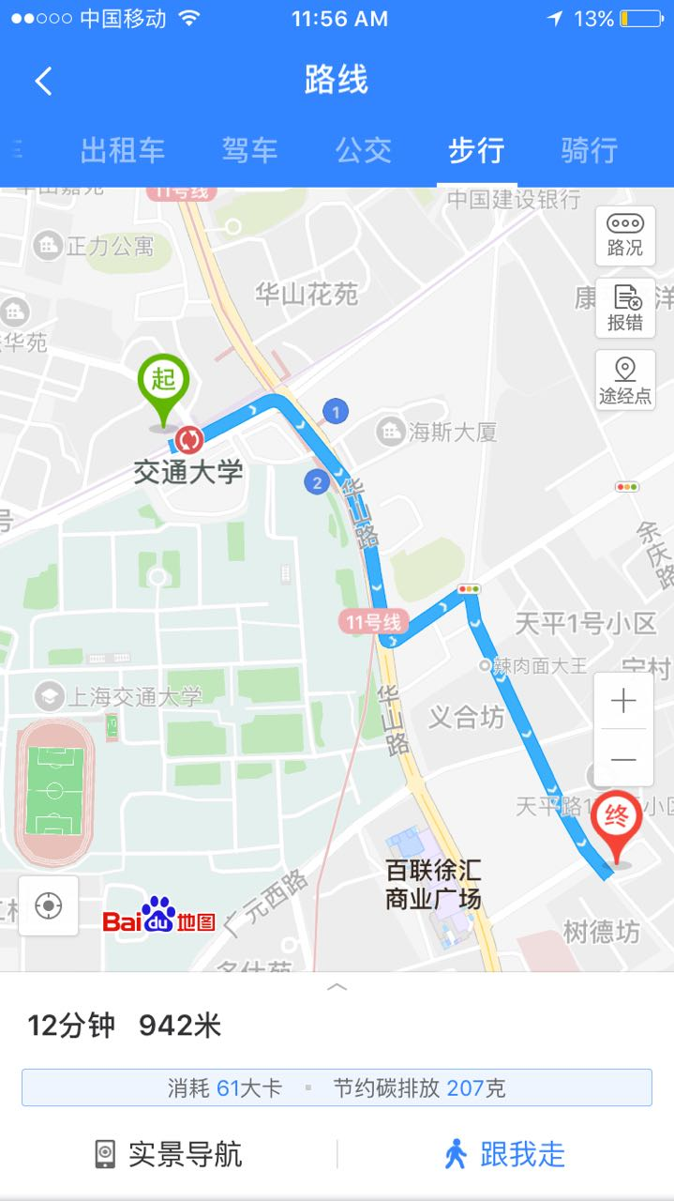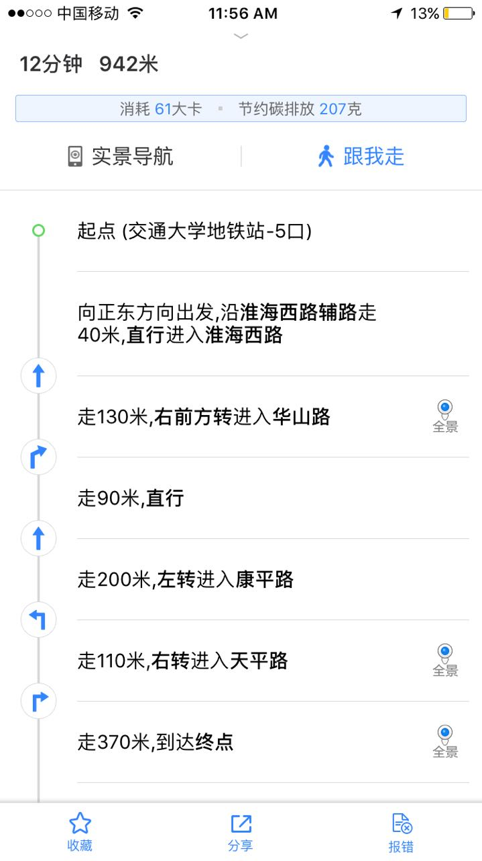
上海轨道交通网络示意图(Shanghai Metro Network Map)
